**RESULTS**

One problem that many people experience is trouble hearing the people around them. One solution to this problem is seen on TV when there are subtitles at the bottom of the screen. Google took this a step forward by making a live transcription app that basically turns real time text into words on the phone screen. One way to take Google's solution a whole step forward is to find a way to display text in front of the user's eye. This can be accomplished with 5 pieces of hardware : Lipo power battery, Things plus arduino board, an android phone , a microphone and finally a transparent display. The first step would be to make an android application that is capable of picking up sound based on pitch and sending the text data of the sound to the arduino using bluetooth. The next step is the program for the arduino to display the text on the transparent display. The third step would be to attach all the components of the project to the glasses and to put the oled screen in front of the glasses. Next is to have a display that sends text to the user's eye. The criteria of this project would be how accurately the user is able to read the subtitles coming out the glasses and the main constraint of this project is with the budget. With a bigger budget, this project would have been a lot easier to make however due to the limited budget, it was a challenge to make this product work.

The hypothesis of this project is that the user will be given accurate subtitles and will be able to effectively read the subtitles without any issues. The null hypothesis is that the user won’t be able to accurately read what is on the display despite the display having the current text. The strength of this project is that the whole design is very compact(The whole project fits one the frame of the glasses). The weakness of this project is that the speech to text api is activated a second after a voice is heard. This effectively cuts off a whole part of the sentence from being registered from the text to speech api. Part of creating glasses that can display nearby voices is the glasses ability to pick up noise. The following charts and tables show the range of sound the microphone this product uses can accurately pick up

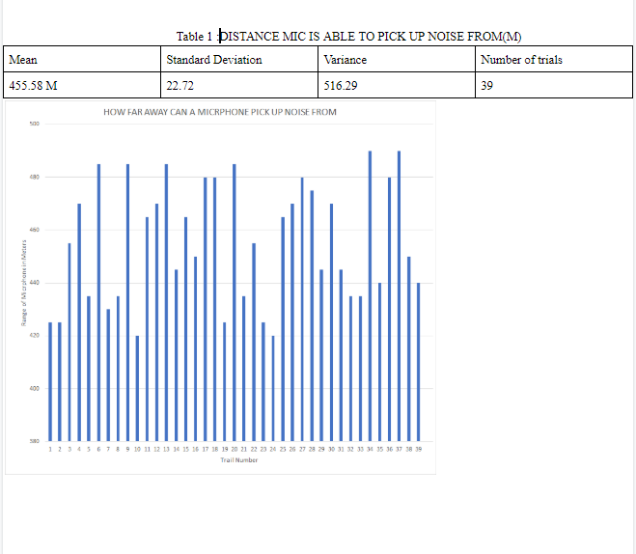

One of the modifications that can improve this project is one that can be more compact. Based on the data, the range of the mic is good. However one way to improve the project is if the mic used was wireless. One wireless microphone that fits the compatibility that will improve the project is rhode’s microphone. They have the world's smallest mic . Using this mic would allow the user to feel more free as they are not required to wear a wire everywhere they go. The reason why this microphone was not used is because of the limited budget this project had. Another modification that can be done is re code the android app in Android App builder. Doing this would allow a more flexible mistake that is more forgiving of mistakes made while talking. For example if the user messed up the sentence I can code android app studios to take that part of the sentence off the text instead of the whole context of the sentence being messed up from the user.

**Conclusion**

The purpose of this project is to make glasses to help people with bad hearing live everyday life normally. The hypothesis of this project is that the user will be given accurate subtitles and will be able to effectively read the subtitles without any issues. The results agree with this hypothesis because the words someone said can be picked up from 500 meters using the microphone the product uses.. One systematic error that happened while conducting this experiment is that people in the hall that we were doing this experiment in started talking. This led to some of the trials ending faster than the majority of trials. One limitation was the lack of funding. If there was more funding the way this product was designed would be fundamentally different as it would have used items that cost well over 200$. The results of this experiment can not be generalized to all microphones as each microphone has a different range depending on factors such as size and price. The producers of this experiment can be improved by making sure there is no noise in the hallway while testing the microphone. One way to improve the project as a whole is to program the app using android studios instead of android app builder. Even though android app builder is an easy drop and drag programming language it does not allow for mobility to truly mess with the code and modify it based on your projects need. With android studios the app could be more flexible by taking out ums from the sentences said by the person and make the product more clear for the user to read as unnecessary parts of the sentence will be removed

REFERENCES

Arduino. (2020). Retrieved October 23, 2019 from <https://www.arduino.cc/>

Austin, N. (2015, March 10). Best. Retrieved October 4, 2019, from https://kitkraft.com/learn/best-glue-for-plastic-guide

Mayon, I. (2017, February 16). Sparkfun Transparent OLED. Retrieved October 3, 2019, from <https://learn.sparkfun.com/tutorials/transparent-graphical-oled-breakout-hookup-guide>.

Murata, Y. (2017, October 25). MIT app builder bluetooth https://www.instructables.com/id/MitAppbuilder/.